PRESS ANNOUNCEMENT

D-Link Showcases New Additions to
Smart Home Portfolio at IFA 2016
Global leader in connectivity to preview new cameras, routers and home automation solutions

Showstoppers @IFA, Berlin – September 1st, 2016 – D-Link, the multinational networking equipment manufacturer, will be previewing its latest range of Smart Home products at the world's leading trade show for consumer electronics, IFA 2016 in Berlin, including a new line of video surveillance cameras, Wi-Fi routers and home automation technology.

The latest additions to D-Link’s Smart Home portfolio build on its dedication to designing, developing and manufacturing easy-to-use, easy-to-install and easy-to- monitor Smart Home devices.

“At D-Link we’re committed to developing Smart Home technology that has customer experience at its heart, and breaks the boundaries of the modern Smart Home,” commented Kevin Wen, President of D-Link Europe. “With more than 30 years’ experience engineering world-class networking and home automation technology, we have the perfect foundation to produce Smart Home solutions that not only give consumers more control of a home or office environment, but are also easy to use and require minimal effort to get up and running.”

Wen continued: “At IFA 2016, we’ll be unveiling a wide selection of our newest products in areas which cater to the growing demand for smarter homes – a need that we have identified, as we have over four million customers on our mydlink™ platform.”

Alongside a range of the latest advanced home video surveillance cameras with revolutionary Wide Eye 180˚ technology, D-Link’s newest products on show at IFA, Hall 25 Stand 110-14 will include:

AC5300 ULTRA Wi-Fi Router (DIR-895L)
D-Link’s AC5300 ULTRA Wi-Fi Router is the perfect option for those who want to get the best performance out of their wireless network. Delivering up to 5300Mbps bandwidth, with eight high-performance external antennae and high-power amplifiers, the DIR-895L delivers improved Wi-Fi range and signal stability throughout a home. Additionally, the DIR-895L supports the latest wave of Wi-Fi technology with MU-MIMO, SmartConnect, and Advanced AC SmartBeam, which boosts wireless performance, distributes data more efficiently, and enables multiple devices to access a high-bandwidth connection simultaneously. This allows multiple users to enjoy Wi-Fi without interruption.

The DIR-895L provides simple Wi-Fi connection for devices, allowing users to create a single secure home network effortlessly with one SSID and security key. The router can be managed and monitored from both the online mydlink portal, and via the mydlink Lite app for iOS, Android and Windows.
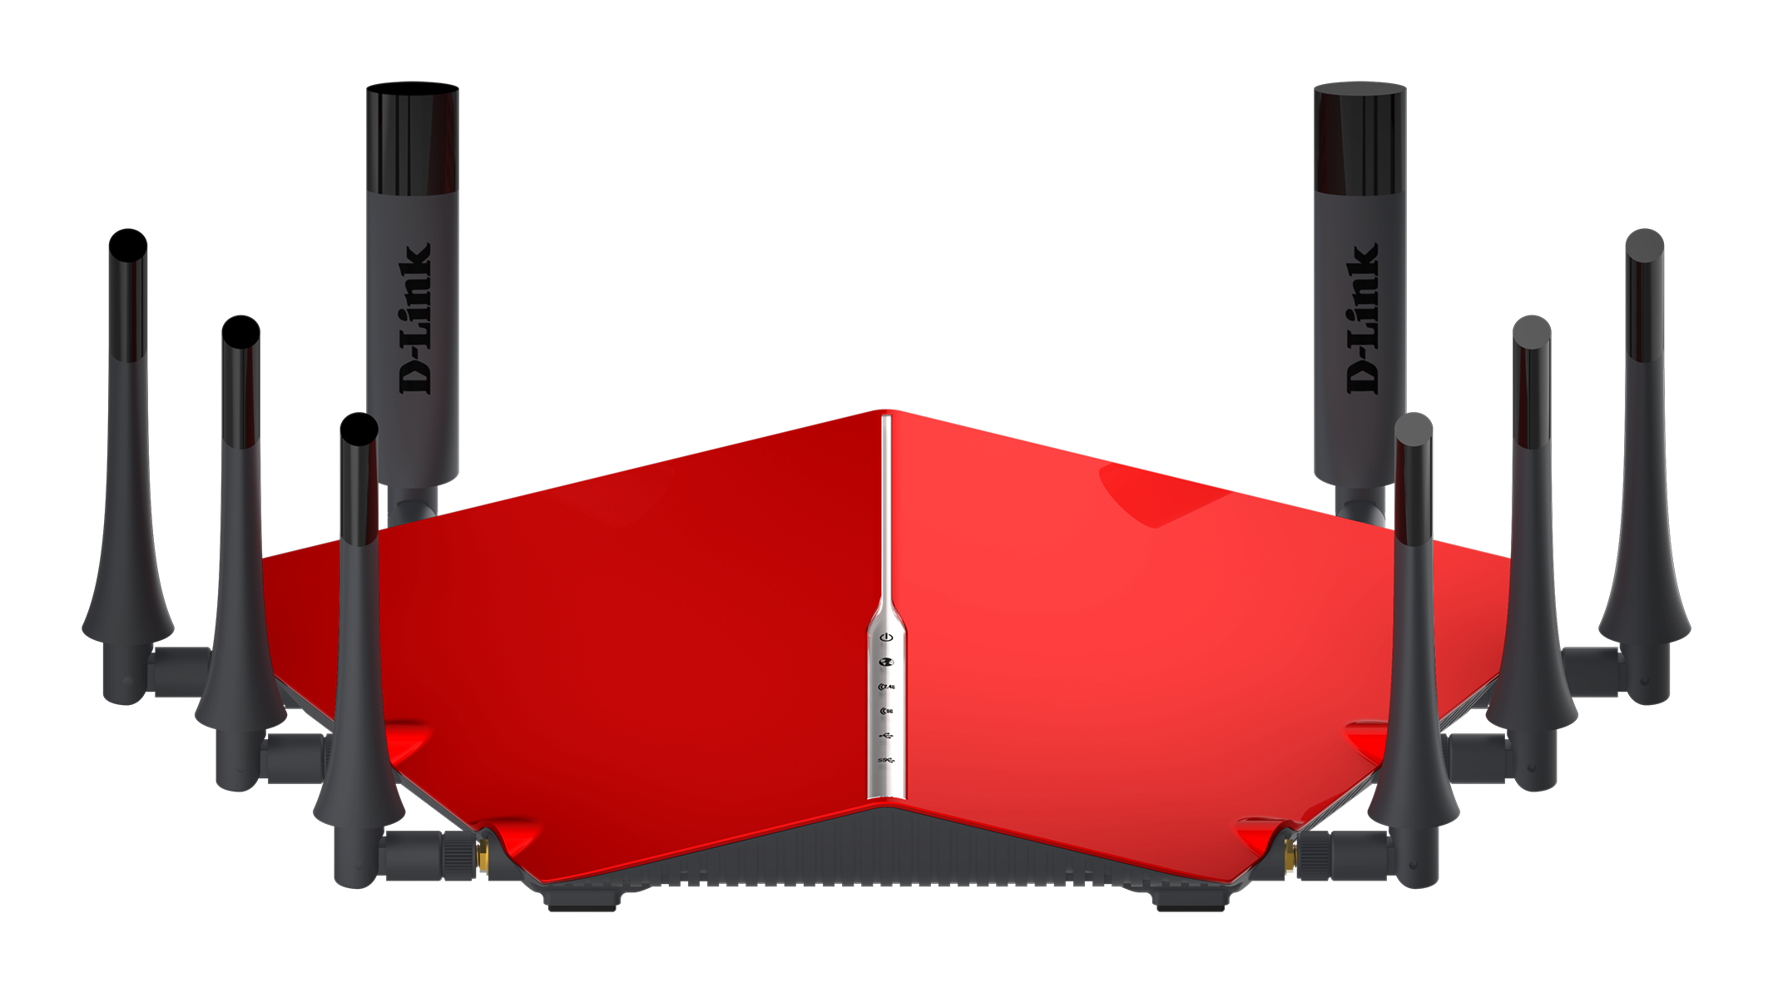

mydlink Home Smart Power Strip (DSP-W245)
The DSP-W245 is a 4-port wireless power strip that is ideal for those taking the first steps to making their home smarter. Once connected to the home Wi-Fi network, the Smart Power Strip can be monitored and managed via the mydlink Home app. Using mydlink Home, users can independently turn on or off all four sockets on the power strip, set individual timers, and review the power consumption of each socket to help manage energy usage, sending push notifications to a user’s mobile device when a pre-set energy limit has been reached.

Additionally, as part of the mydlink Home ecosystem, the Smart Power Strip can be triggered by other D-Link connected home devices, such as a Water Sensor, Door & Window Sensor, and Smoke Detector. For example, users can provide power to a socket with a lamp plugged in when a Door Sensor detects the front door opening or if the Smoke Detector is activated.

mydlink Home Thermostatic Radiator Valve (DCH-Z410)
D-Link’s Thermostatic Radiator Valve (TRV) efficiently and smartly helps to manage home heating requirements. Along with all the functionality of a traditional TRV, the DCH-Z410 is part of the mydlink Home ecosystem and therefore works and interacts with the other mydlink Home devices. It can be controlled remotely via the mydlink Home app, where users have the ability to not only turn the TRV on or off on-demand, but configure room temperature preferences to individual smart TRV’s around a property, set the valve opening degree and lock the device for child safety. The TRV connects to any Wi-Fi network via the mydlink Home Connected Home Hub.
Availability and Pricing
Contact your local D-Link office for more information
http://www.dlink.com

END OF ANNOUNCEMENT

About D-Link

D-Link has designed, developed and manufactured award-winning networking, wireless, video surveillance, storage and home automation solutions for 30 years. As a global leader in connectivity, D-Link is transforming business networks and equipping businesses to operate more efficiently. It is also a key enabler of the Smart Home, making it easy and affordable for people around the world to monitor, automate and control their home from anywhere, any time using their smartphone or tablet.

D-Link’s extensive range of innovative, high-performing and intuitive technologies are available for both businesses and consumers through its global network of channel and retail partners and service providers.
Follow us on our social media channels: Facebook, Twitter and LinkedIn.

Press Contacts:

Mary Harrison
Head of European Marketing
D-Link Europe
+44 (0)20 8955 9000
mary.harrison@dlink.com

D-Link and D-Link logos are trademarks or registered trademarks of D-Link Corporation or its subsidiaries. All other third party marks mentioned herein may be trademarks of their respective owners. Copyright © 2016. D-Link. All Rights Reserved

