PRESS ANNOUNCEMENT

D-Link Previews New Surveillance Cameras at IFA 2016
New additions include four new video Surveillance Cameras and revolutionary 180º Wide-Eye technology

Showstoppers @IFA, Berlin – September 1st, 2016 – D-Link, the multinational networking equipment manufacturer, has unveiled its latest range of advanced High Definition surveillance cameras at the world's leading trade show for consumer electronics, IFA 2016 in Berlin. This includes advanced 180º Wide-Eye camera technology that offers unparalleled surveillance of a home or office from a single camera without the need for pan, tilt or additional cameras for more visibility.

The latest additions to D-Link’s extensive range of video surveillance cameras bring a broader selection of monitoring capabilities for those looking to keep their home secure. As with all of D-Link’s cameras, the new cameras have been developed with ease of use and functionality top of mind - and are showcased at the event in Hall 25, Stand 110-14.

“The demand for video surveillance technology in the home, especially as part of a Smart Home, is gaining momentum. In a recent survey we conducted across Europe, exploring consumers’ needs of a smarter, connected home, we found that video surveillance cameras are one of the two most popular Smart Home products people are looking to purchase this year,” commented Kevin Wen, President of D-Link Europe.

“With this in mind, D-Link is committed to developing quality, easy-to-use video surveillance cameras and Smart Home technologies so that no matter where they are, people can rest in the knowledge that their home is safe and secure,” Wen continued. “For this reason we understand that a limited view of an area wasn’t enough for the modern home or office.”

The products D-Link will be previewing at IFA 2016 include:

mydlink Home Full HD Outdoor 180º Wi-Fi Camera (DCS-8700LH)
The Full HD Outdoor 180º Wi-Fi Camera (DCS-8700LH) is designed for outdoor surveillance applications and detailed remote monitoring. Thanks to its discrete form factor, 1080 pixel resolution and 180º Wide-Eye lens, the DCS-8700LH is ideal for those looking for an easy to install camera that can monitor a wide area.

The camera’s 180º Wide-Eye lens features de-warping technology, enabling users to have an incredible panoramic view without distortion. The DCS-8700LH is mydlink™ Home enabled, which provides user-friendly setup, instant remote viewing through the mydlink Home mobile app and enables the DCS-8700LH to interconnect with other members of the mydlink Home product family. This can trigger other devices and work in partnership to monitor a home or office.

mydlink Home Monitor HD (DCS-935LH)
The mydlink Home Monitor HD (DCS-935LH) is a full colour, high definition 720 pixel camera with one-way audio. As one of the easiest cameras to install, the DCS-935LH will securely connect to a home W-Fi network with the push of a button and without the need of an additional control hub. The camera’s compact design means it can be discreetly placed in any area of a home or office and, as part of the mydlink Home ecosystem, the DCS-935LH works with other mydlink Home smart devices.

Without complicated setup, installation cost or monthly subscription charges, the camera provides crystal-clear night vision up to five metres thanks to its infrared illuminators. Additionally, when motion or sound is detected the DCS-935LH will automatically begin recording and alert users with push notifications, as the camera comes with a microSD card slot it can record directly on to the camera, removing the need for users to install a separate device to store video recordings.

Full HD 180º Panoramic Camera (DCS-2530L)
The DCS-2530L boasts a 180° Wide-Eye lens that easily captures an entire room, wall-to-wall, in high-quality 1080 pixels with a single camera, without distorting the final image seen by the user. The camera’s rotatable head makes ceiling installations easy, and it has built-in night vision of up to five metres, plus motion and sound detection. Connection to the mydlink online portal, and mydlink Lite app for iOS, Android and Windows allows users to know exactly what is happening, day or night, from wherever they are. The DCS-2530L also features an integrated microSD card slot which allows video to be recorded directly onto the camera, without the need of a computer, and can be triggered to kick into action only when motion or sound is detected.

HD Wi-Fi Camera (DCS-936L)
An ideal all-in-one entry level camera, the DCS-936L provides users with round-the-clock visibility of a room using D-Link’s light leak prevention technology and the camera’s infrared LED lens, which can enable up to eight metres of vision in low light or at night. The DCS-936L is easy to install, featuring an in-built Wi-Fi signal locator LED to indicate when the camera is positioned in the best Wi-Fi spot. Users can easily access the camera via the secure mydlink online portal and mydlink Lite app from anywhere in the world ensuring users can keep tabs on their home no matter where they are.

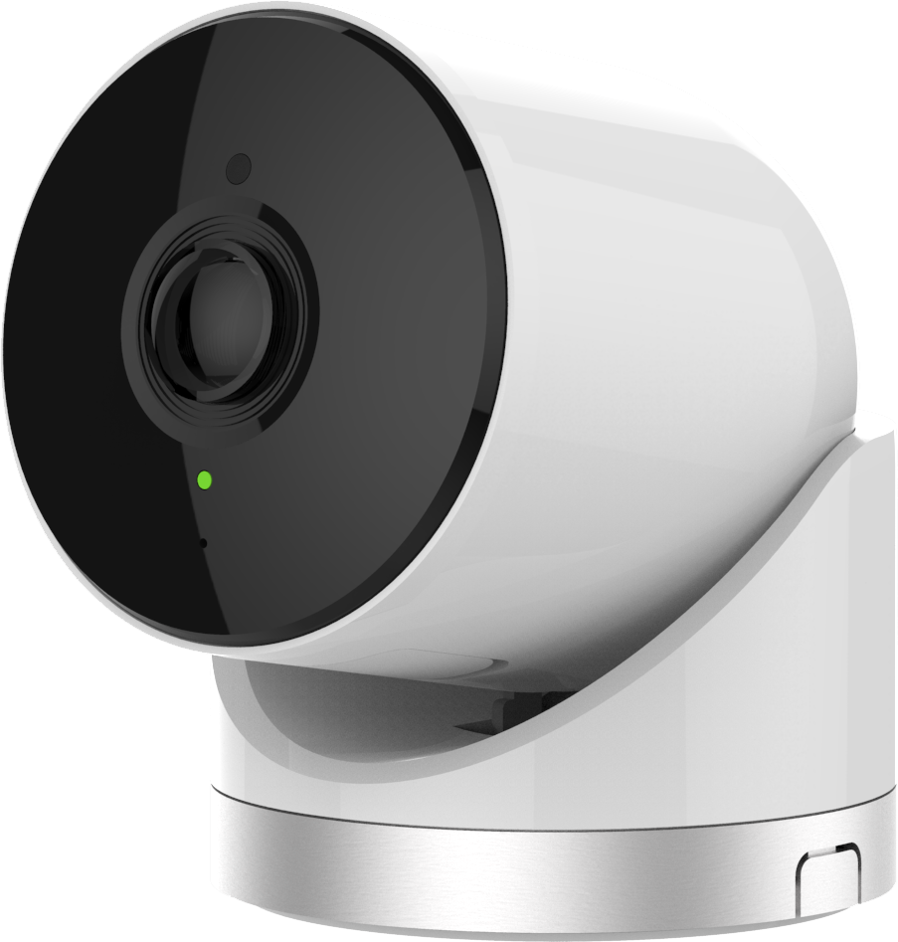  DCS-8700LH | 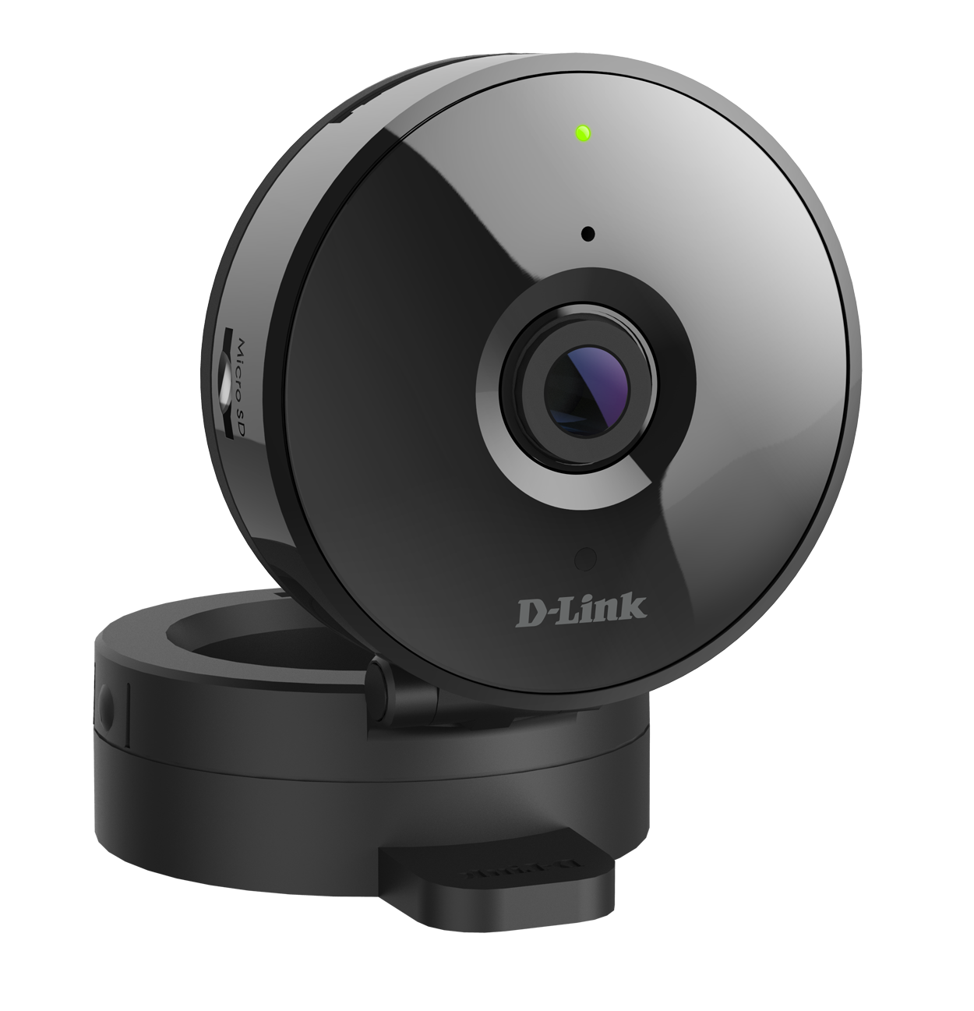  DCS-936L
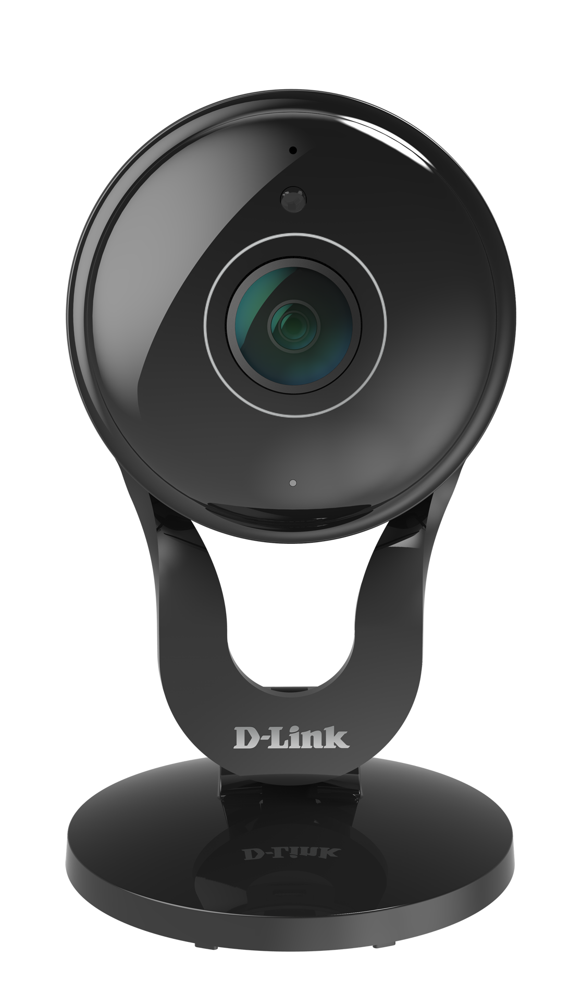  DCS-2530L | 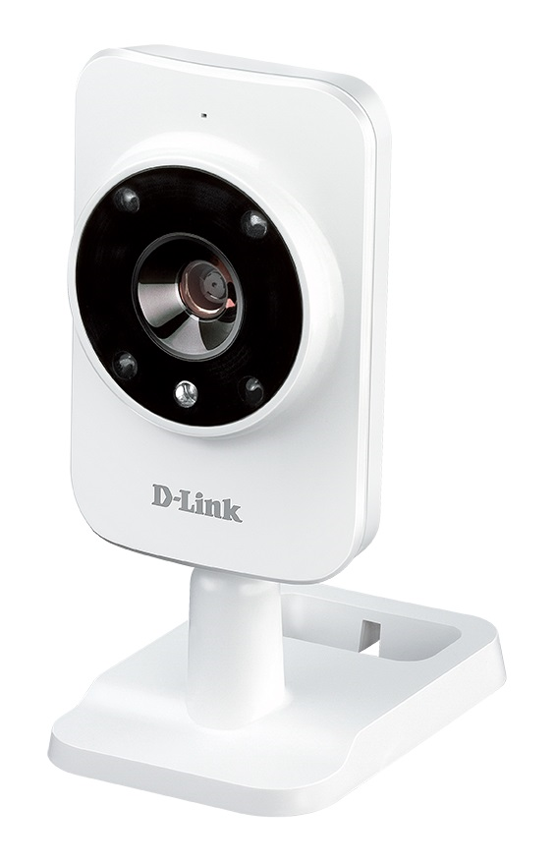  DCS-935LH

Availability and Pricing

Contact your local D-Link office for more information
http://www.dlink.com

END OF ANNOUNCEMENT

About D-Link

D-Link has designed, developed and manufactured award-winning networking, wireless, video surveillance, storage and home automation solutions for 30 years. As a global leader in connectivity, D-Link is transforming business networks and equipping businesses to operate more efficiently. It is also a key enabler of the smart home, making it easy and affordable for people around the world to monitor, automate and control their home from anywhere, any time using their smartphone or tablet.

D-Link’s extensive range of innovative, high-performing and intuitive technologies are available for both businesses and consumers through its global network of channel and retail partners and service providers.

Follow us on our social media channels: Facebook, Twitter and LinkedIn.

Press Contacts:

Mary Harrison
Head of European Marketing
D-Link Europe
+44 (0)20 8955 9000
mary.harrison@dlink.com

D-Link and D-Link logos are trademarks or registered trademarks of D-Link Corporation or its subsidiaries. All other third party marks mentioned herein may be trademarks of their respective owners. Copyright © 2016.
D-Link. All Rights Reserved

