Table of Contents

Company 2
Design and Innovation 3
Key Product Lines 4
Customers 6
Leadership 7
Employees 7
Corporate Standards 7
Headquarters 8
Values 9
Appendix 10

Company
D-Link was founded in 1986 with a mission to bring high-quality computer networking solutions to consumers and businesses of all sizes. 30 years later, the company has developed into a billion-dollar global enterprise operating in 67 countries, with an extensive portfolio of award-winning networking and home automation products and services. Today, D-Link continues to empower its customers around the world in a fast-paced, evolving, and fiercely competitive environment.
D-Link provides high-performance and cost-effective solutions that deliver better connectivity, security, efficiency, and cost savings for the home and office. The company prides itself on pioneering green technologies that save energy without compromising on reliability. With more than 189 locations worldwide, D-Link understands and delivers on the individual needs of its customers and partners, offering unparalleled care and support in every market.
After three decades of pioneering innovation and spectacular growth, D-Link has secured its position as one of the world’s leading technology providers, and developed as a lifestyle brand through its entry into the smart home category with the launch of mydlink™ Home. This ever growing ecosystem of smart home devices gives users the flexibility to monitor, automate and control their home from anywhere, anytime using their smartphone or tablet.
2016 marks D-Link’s 30th year in the industry – a time spent designing, developing and manufacturing market-leading networking, wireless, storage, security, video surveillance and home automation solutions. Looking forward, D-Link is excited for what the future holds, as it continues to develop innovative, high-performing and intuitive products, solutions and applications for both businesses and consumers.
More information can be found on our website, and our social media channels: Facebook, Twitter and LinkedIn

Design and Innovation
D-Link’s commitment to innovation has been widely recognised over the past 30 years having received a large number of product design awards from esteemed organisations such as the International Design Excellence Award (IDEA) program, red dot, and International Forum (iF) Design. D-Link’s international team of engineers have made their mark on the development of the evolving modern home and business networking environment - which many today take for granted. The company has been awarded patents and copyrights on a variety of technology platforms, including Application Specific Integrated Circuit (ASIC) computer chips, hardware technology designs, software applications and other intellectual property.
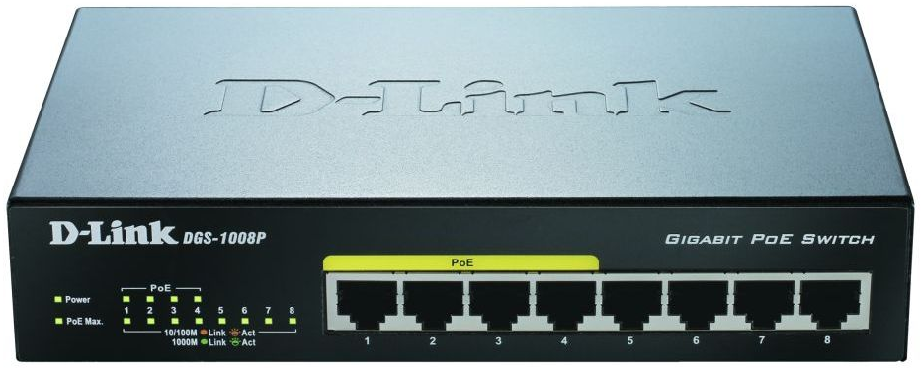
As a key contributor to the Digital Home Working Group (DHWG), D-Link embraces industry standards as criterion for new and innovative connectivity and communications solutions, for both home and business. D-Link’s entire range of products are certified by the FCC, the Wi-Fi Alliance, CableLabs and BT Openreach MCT testing process, and the company is also an affiliate of Thread, a member of the AllSeen Alliance and a certified vendor of Apple HomeKit / MFi licensing program.

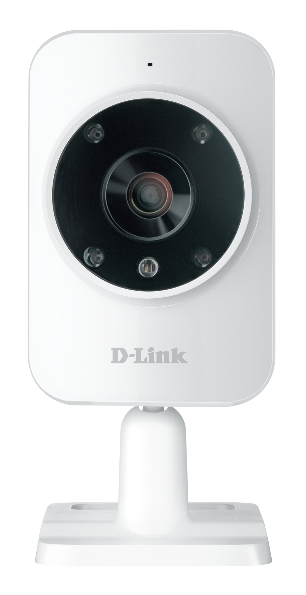
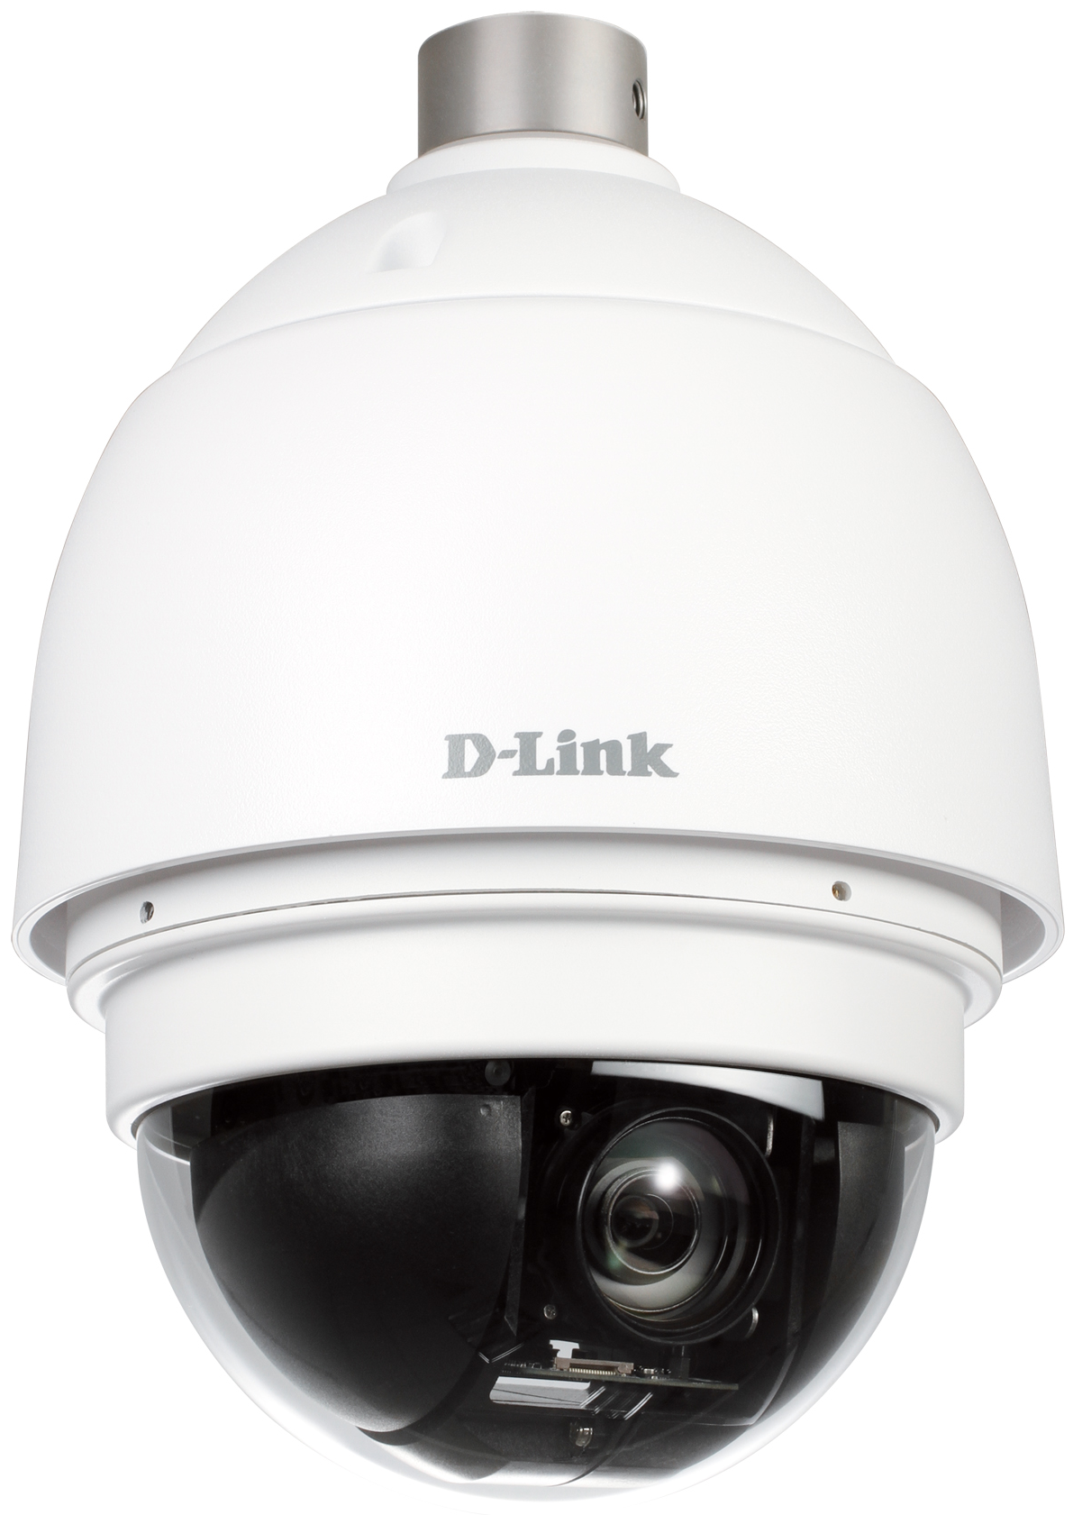
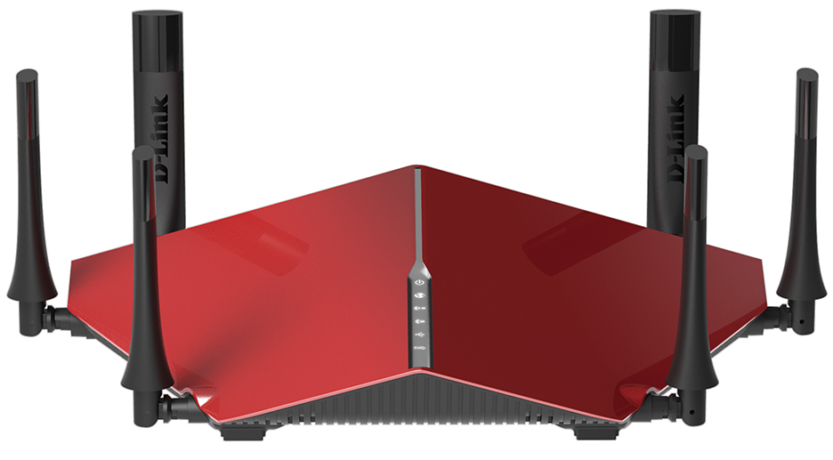
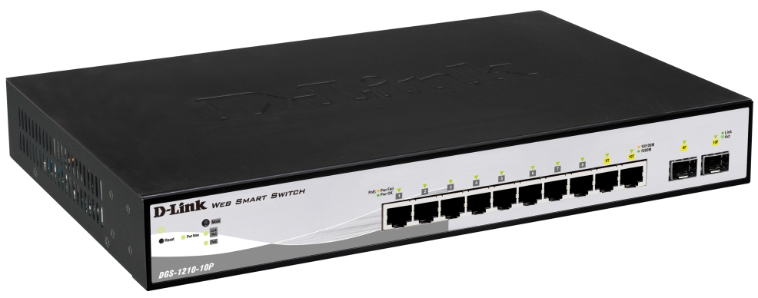

Key Product Lines
mydlink™ Home
An ecosystem of smart home technology - the mydlink™ Home range give users complete control and flexibility to keep a watchful eye on their home, with a wide range of devices including monitors, a water sensor, a smoke detector, sirens, motion sensors, a door & window sensor, and smart plugs.

These can all be connected using the mydlink™ Home Connected Home Hub, which brings together all of the mydlink™ Home smart devices as the gateway between a consumer’s existing Wi-Fi network and all mydlink™ Home devices. It allows the range to co-exist on a network so they can talk directly to each other, creating a truly connected ecosystem.

The mydlink™ Home range also includes two starter kits to help kick start the connected home or office, combining some of the most popular products from the mydlink™ Home portfolio. The Smart Home HD and Smart Home Security Starter Kits make it really easy and affordable to automate a home, and are designed to help control, protect and monitor a home.

All smart home products are controlled by the free mydlink™ Home app, so users can secure, connect and automate their home from anywhere, anytime using their smartphone or tablet. Via the app, products can be programmed to talk to each other in a seamless, intelligent way, providing numerous options to address different scenarios. For example, a motion sensor triggering a lamp to turn on when movement is detected.

mydlink™ Home Music Everywhere
Converts old speaker technology with a standard 3.5mm audio jack into wireless speakers for streaming music around the home from any Android or iOS device.
Baby and Pet Monitors
D-Link’s EyeOn Baby and Pet Monitors are especially designed to help parents and pet owners to keep an eye on what matters most - no matter where they are.
Wired and Wireless Home Networking
D-Link is a dominant player in both wired and wireless home networking, with award-winning products that are both powerful and easy to use. This includes an extensive range of wireless routers, access points, extenders and adapters supporting the latest Wireless AC technology, as well as PowerLine networking and Ethernet switches.
Network Storage
D-Link home storage enclosures are ideal for users who need to store and share their library of digital music, video, photos, and back up important documents.

mydlink™ Cloud Services
mydlink™ Cloud Services allow users to effortlessly access, share, view and control mydlink™-enabled devices on the home network from anywhere, anytime. Wi-Fi routers, cameras and storage devices can all be reached instantly through a web browser on a computer or through the free app on smartphones and tablets, putting users in control of their network no matter where they happen to be.
Mobile Solutions
D-Link 3G/4G LTE dongles and mobile hotspots allow users to stay connected and share a single mobile internet connection with multiple devices.
Video Surveillance
D-Link's full-featured range of Video Surveillance network cameras provide remote audio/video monitoring and recording to local or remote storage and include the world’s first Wireless AC camera that offers a real-time 180° view of a room, without any delay.

Enterprise Switch
D-Link business-class Ethernet switching products provide small to medium enterprises (SMEs) with performance-leading solutions at competitive price points. As the foundation for a full range of high-value network solutions, D-Link Network Switches enable SMEs to manage physical security, an end-to-end wireless infrastructure or protect and store sensitive data. The extensive range of D-Link switches enables businesses to power and connect with more devices simultaneously.
Enterprise Wireless
D-Link business wireless solutions are designed for businesses that require extensive feature sets for both indoor and outdoor WLAN applications, as well as enterprise-class security. Unified wireless solutions and support for the latest Wireless AC standard allow businesses to maximise their wireless network potential.
Enterprise Storage
D-Link's enterprise storage solutions include Network Attached Storage (NAS) as well as iSCSI Storage Area Network (SAN) products to provide reliable network data storage for business customers.

Customers
D-Link’s ambition is to nurture a truly customer-focused culture by providing service with a personal touch. With this in mind, the company adopted a “globally local” service model. From its strategically located bases around the world, comprised of the best local talent and ambitious technologists, each local office has a strong understanding of the demands of its regional market. D-Link routinely sets yearly goals to increase customer satisfaction – including customer feedback, which plays a significant role in product development and support process.
D-Link strives to serve customers with respect, knowledge, and personal attention - regardless of whether the customer is an individual consumer or a large corporation. By taking this approach, D-Link consistently provides high quality of service and care to millions of people around the world.

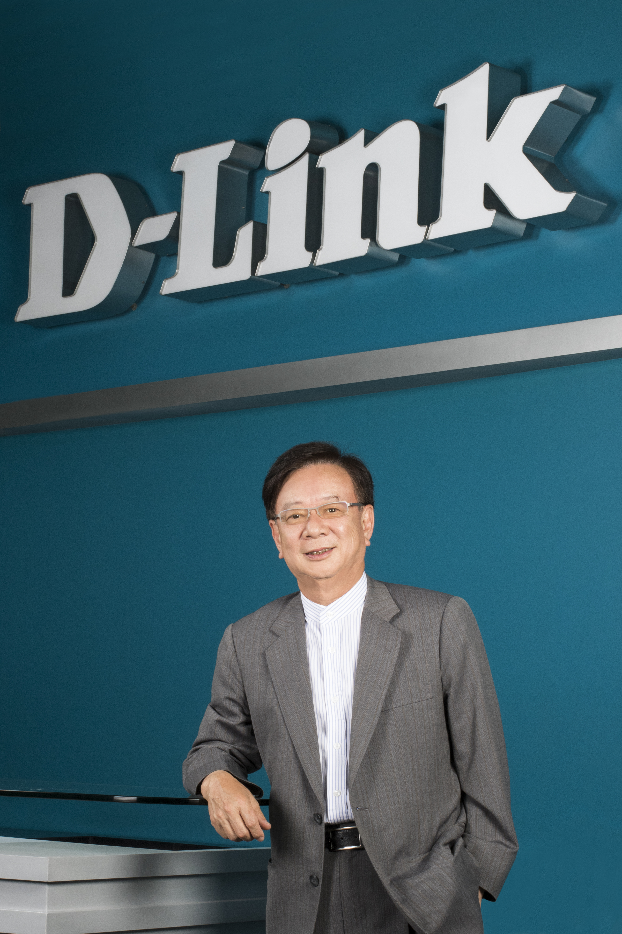
Leadership
John Hsuan | Chairman (pictured)
Douglas Hsiao | Vice Chairman and CEO
Anny Wei | President
Yun-Wei Investment Co. Ltd. | Director
Douglas Hsiao | Director
John Lee | Director
Jo-Kong Investment Ltd. | Director
Kenneth Tai | Director
Alpha Networks Inc. | Director
Shih Kuo Lin | Director
Fred Fong | Independent Director
Shyang-Fong Chung | Independent Director
Jie-Shiun Investment Co. Ltd. | Supervisor

Employees
D-Link Corporation has more than 2,700 employees worldwide and, as a company, believes in fostering an environment where a team of highly motivated, action-oriented talent works together to continuously create and deliver high-quality, innovative products and services. This atmosphere, combined with D-Link's vision, mission, and culture, provides the assurance of exceptional service delivery with a personal touch.

Corporate Standards
D-Link is committed to maintaining a high standard of ethics, corporate governance, and effective accountability mechanisms in every aspect of its operations. Conducting business in a socially responsible and honest manner that serves both the company and shareholders' long-term interests.
D-Link has an internal audit office and supervisors to ensure proper reporting and adequate internal controls. Measures to safeguard shareholders' interests include an effective board of directors and the prompt disclosure of relevant information to shareholders. D-Link maintains high transparency with the timely release of information to shareholders and investors.

Headquarters
D-Link's international headquarters are located in Taipei, Taiwan (R.O.C). Global offices serve regional headquarters in North America, Asia, and Europe. D-Link maintains strategic operations in the United States, Canada, the United Kingdom, Germany, France, Spain, Italy, Greece, Sweden, Denmark, Finland, Turkey, Russia, Israel, the Middle East, South Africa, Chile, Australia, Japan, Vietnam, Singapore, China, India and numerous other countries on five continents.
D-Link Corporation
No. 289 Xinhu 3rd Road
Neihu, Taipei 114
Taiwan
TEL: +886-2-6600-0123
FAX: +886-2-6600-9898
URL: www.dlink.com.tw

Key Offices
Please refer to Appendix.

Values
Several core values form the foundation for D-Link’s successful operations:

Entrepreneurship
Regardless of their role, all employees are encouraged to approach their job with a spirit of entrepreneurship. Fresh ideas, new approaches, and enhanced processes are regularly adopted by company leadership.
Professionalism - D-Link employees behave professionally at work and when communicating with customers and stakeholders.
Empowerment - D-Link empowers all of its employees to act as leaders.

Accountability
Employees are accountable to themselves and to each other.
Responsibility - D-Link has a responsibility to its stakeholders, to always do the right thing no matter the cost.
Perseverance - Employees tackle and solve problems every day, persevering in the face of challenges.

Teamwork
Nothing can be accomplished unless stakeholders can work together. Teamwork is the fabric of D-Link’s daily operations.
Synergy - D-Link takes advantage of everyone’s strengths to optimise projects and daily operations.
Solidarity - Employees work together with a shared vision in an effort to achieve their goals and fulfil their mission.

Integrity
Integrity is at the heart of a truly successful enterprise. D-Link does all it can to earn and maintain the trust of its customers.
Trustworthiness - D-Link understands that its integrity as a brand depends on the integrity of its employees.
Reliability - Company stakeholders can rely on each other. D-Link customers can rely on D-Link products.

Appendix
Key Offices

Adria
Cvjetno naselje II 18
10000 Zagreb
Croatia
TEL: +385 (1) 6189 145

Australia
Ground Floor, 6-10 Talavera Road
North Ryde, NSW 2113
Australia
TEL: +61 (1) 300 700 100

Brazil
Rua Geraldo Flausino Gomes no. 78 -80
andar, conjuntos 81,82, 83 e 84, Cicade
Moçöes – São Paulo – SP
Brazil
TEL: +55-11-2185-9320

Bulgaria
6 Mihail Tenev Str., Floor 5, Office 5.3
Sofia 1784
Bulgaria
TEL: +3592 958 2242

Canada
2525 Meadowvale Boulevard
Mississauga, Ontario L5N 5S2
Canada
TEL: 800.354.6522

China
8F, 1#, NO.641 Tianshan Road
Shanghai 200336
China
TEL: +86-21-5206-8899

Czech Republic
Building City Empiria, 15th fl.
Na Strzi 65/1702
140 62 Prague 4
Czech Republic TEL: +420 211 151 640
Denmark
Hørskætten 14-16
DK-2630 Taastrup
Denmark
TEL: +45-43-969040

Egypt
P.O. Box: 18224
Plot No. S31102
Jebel Ali Free Zone - South
Dubai, United Arab Emirates
TEL: +20 2267 38470

Europe, UK & Ireland
D-Link House, Abbey Road
London, NW10 7BX
United Kingdom
TEL: +44-20-8955-9000

France
41 Boulevard Vauban
78280 Guyancourt
France
TEL: +33 1 30 23 86 88

Germany
Schwalbacher Strasse 74
D-65760 Eschborn
Germany
TEL: +49-6196-77990

Greece
IT LAB, 38 Michalakopoulou Av.
115 28 Athens
Greece
TEL: +30 210 866 5710

Hungary
Robert Karoly Korut 59
H-1134 Budapest
Hungary
TEL: +36 1 461 30 00
India
Kalpataru Square, 2nd Floor
Unit No. 24, Kondivita Lane
Next to VITS Hotel
Off Andheri Kurla Road, Andheri East
Mumbai - 400059
TEL: 91-22-2921-5700

Iran
No.11, 6th alley (Araabi St.)
Sanaee st. Karim Khan Ave
TEL: +98-21-888-80918, +98 (21) 883-18295, 96

Israel
20 Ha-Magshimim Str.
Kiryat Matalon, Petach Tikva,
49348
Israel
TEL: +972-3-9215173
Italy
Via Negroli 35
20133 Milan
Italy
TEL: +39-02-9289-8000
c/o Regus
Via Luca Gaurico 9/11
00143 Rome
Italy
TEL: +39-06 5843 1

Japan
SOWA Gotanda Building 2F
Higashigotanda 2-7-18
141-0022, Japan
TEL +81-3-5792-5100
Kenya
The Mall, Westlands
1st Floor, Shop no. 1F05
Nairobi
Kenya
Tel: 254 20 4452816

Kingdom of Saudi Arabia
P.O. Box: 18224
Plot No. S31102
Jebel Ali Free Zone - South
Dubai, United Arab Emirates
TEL: +966-26522951, +966-12170009

Korea
Rm 306 Samsung IT Valley,
197-5, Guro-Dong, Guro-Gu
Seoul 150-050
Korea
TEL: +82-2-2028-1810

Latin America
Avenue Vitacura 2939, Piso 6
Edi¬cio Millenium,
Las Condes, Santiago
Chile
TEL: +56-2-5838-950

Mexico
Calle Lago Alberto
No. 319 Int. Piso 6
Colonia Granadas, DEL. MIGUEL HIDALGO
Mexico, D.F. CP 11520
TEL: (52 55) 420 93 100

Middle East
P.O. Box 18224, Plot No. S31102
Jebel Ali Free Zone - South, Dubai
United Arab Emirates
TEL: +971-4-8809033

Morocco
M.I.T.C
Route de Nouaceur angle RS et CT
1029 Bureau N° 312 ET 337
Casablanca, Morocco

Nigeria
52A Campbell Street
Lagos Island, Lagos State
Nigeria
TEL: 234 1 8536769

Pakistan
P.O. Box: 18224
Plot No. S31102
Jebel Ali Free Zone - South
Dubai, United Arab Emirates
TEL: +9221-4548310

Poland
ul. Olkuska 7
02-604 Warszawa
Poland
TEL: +48 22 379 72 00

Romania
7A Bucuresti-Ploiesti Avenue, 3rd Floor
Bucharest
Romania
TEL: +40 21 202 3175

Russia
Grafsky per., 14, oor 3
Moscow, 129626
Russia
TEL: +7-495-744-0099

Singapore
1 International Business Park
#03-12 The Synergy
Singapore 609917
TEL: +65-6774-6233

South Africa
P.O. Box: 18224
Plot No. S31102
Jebel Ali Free Zone - South
Dubai, United Arab Emirates
TEL: +971 4 8809022

Spain
Calle Muntaner, 239-253, Floor 3º B
08021 Barcelona
Spain
TEL: +34 93 409 0770

Spain
Ctra. Canillas, 17
28043 Madrid
Spain
TEL: +34 91 759 6540

Sweden
Gustavslundsvägen 151B
S-167 15 Bromma
Sweden
TEL: +46-(0)8564-61900

Taiwan
No. 289 Sinhu 3rd Road
Neihu, Taipei 114
Taiwan
TEL: +886-2-6600-0123

Turkey
Büyükdere Cad. Ferro Plaza
No: 155 Kat:1 Daire:1
Zincirlikuyu
Istanbul
Turkey
Tel: +90 212 289 5659

U.S.A.
17595 Mt. Herrmann Street
Fountain Valley, CA 92708
USA
TEL: +1.800.326.1688

