You Deserve Better!

Monster® ClarityHD™ Headphones Go Wireless; On-Ear and In-Ear
Models Evolve Line with Latest Technologies at Prices Everyone Can Afford

Bluetooth models are clearly the better choice with better sound, more comfort and cooler tech for everyone living the mobile lifestyle

BERLIN, Germany, September 2, 2016 – Monster®, the world leader in personal audio and high-performance headphones, is delighted to announce that the first On-Ear Bluetooth model (MSRP $149.95 / €149.95 / £129.95) of its popular ClarityHD headphones wireless is now available. In keeping with the company’s vision for the line, the Monster ClarityHD On-Ear Bluetooth model offers sound quality and features that surpass the competition and consumers’ expectations at its price point, making great audio available to all users of smartphones and portable devices. These On-Ear and In-Ear Bluetooth models, follow the popular ClarityHD wired In-Ear model, which was the first offering in the line that was introduced in 2015.
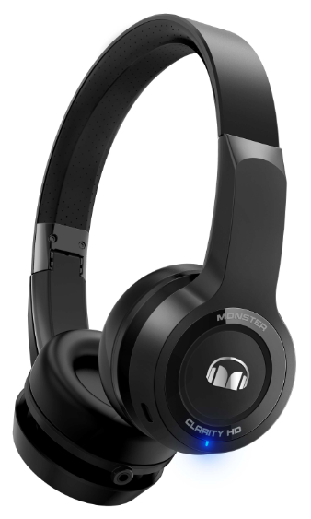
Monster ClarityHD On-Ear Bluetooth headphones offer industry-leading sound and flexible listening options. Apt-X enables superior and reliable wireless audio reproduction, and users can select from two sound profiles (natural and super dynamic) to match their mood or taste. They can even be used to listen to music from wired or USB Audio sources including compatible smart phones, tablets, and PCs.

The Monster ClarityHD On-Ears have a sleek low-profile modern design and feel as good as they sound, with ultra-soft ear cushions, and a concealed adjustable headband with non-slip silicone. Providing even more bang for the buck and an added cool factor, this model offers cutting-edge swipe controls for play/pause, tracking and volume functions. Built-in high-intelligibility mics and Active Echo Suppression enable crystal clear calls.
“Our Monster ClarityHD line began with our declaration of war on the crappy generic earbuds that are packaged with cell phones, tablets and other portable devices. These are an afterthought for the device makers and should not be seen as anything more by consumers. The initial idea behind our ‘You Deserve Better’ campaign really caught on. As a result, we decided to take the war on crappy earbuds to the air with headphones that offer high-performance wireless for the price of wired models—and we dare consumers to compare against other models in the category in terms of sound, performance, advanced features and price. No matter what your budget, ClarityHD headphones are designed to bring your personal audio experience out of the dark ages of substandard headphones.”

Better Build
ClarityHD™ headphones let users experience Monster’s world-renowned craftsmanship and cool tech. The reinforcement of critical stress points protects them from wear and tear and breakage that is common with many “value” models. Folding design, swipe controls and high-intelligibility mics are just a few examples of the advanced features they offer for a great price.

Better Comfort - The Monster ClarityHD™ headphones are deigned to fit perfectly no matter what your ear shape or size. The On-Ear models provide ultra-soft ear cushions and a concealed adjustable headband with non-slip silicone for great comfort and stability while users walk, work or bop their heads to the music. The In-Ear models feature a patent applied oblique cone shaped front housing and a variety of soft-tip sizes that conform to any ear shape, enabling them to remain perfectly snug and comfortable during any activity—to the point that users don’t even know they have them on. The in-ear model also features an ultra-thin round cable that won’t stick to users’ necks. In both cases, durable and lightweight materials, as well as sleek design, combine to power longer listening sessions without soreness or ear fatigue.

Better Wireless - The ClarityHD™ Bluetooth headphones reliably reproduce music wirelessly for more enjoyment between charges - which are not required frequently. The In-Ear models feature a dual battery design for double the life and all day listening, while the On-Ear models also enable listening around the clock. In real world terms, as people tend not to listen to headphones for hours on end without interruption, both models can provide days or weeks of use between charges. When charging is necessary, it is easy via a USB charging port.

Better Sound - ClarityHD™ Bluetooth models deliver premium sound custom tuned by the experts at Monster. Both the In Ear and On Ear headphones offer vibrant attack dynamics for horns and percussion instruments, rich, lifelike vocals, and powerful bass and crystal-clear high frequencies.

Better Calls - Thanks to Universal ControlTalk® controls, users can take a call, shuffle music, skip a track or adjust volume. Additionally, the high intelligibility microphone is placed at the optimal angle and, along with Active Echo Suppression, they deliver crystal-clear calls.

Better Isolation - On-Ear and In-Ear models provide superior noise isolation - great for focusing on the music while working or studying. They also effectively reduce plane engine drone and other ambient noise while travelling.

Monster ClarityHD™ On-Ear Bluetooth headphones will be available in an attractive black finish (MSRP $149.95 / €149.95 / £129.95).
Monster ClarityHD Bluetooth In Ears are now available in black and black platinum, and white & chrome (MSRP $79.95 / €79.95 / £69.95).
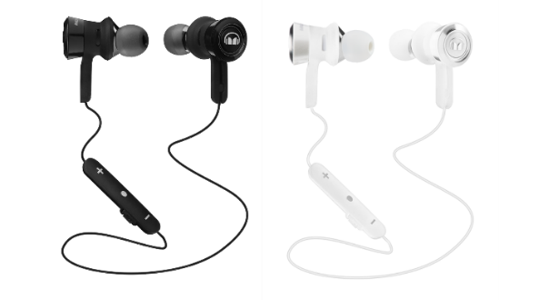
Monster ClarityHD Wired In-Ears are also now available in black, white, green and pink (MSRP $39.95 / €39.95 / £34.95).
All models can be purchased at monsterproducts.com / monsterproducts.eu and selected retail stores.

ABOUT MONSTER
For the past 35 years, Monster® has been a catalyst for innovation and big ideas. Discovering that cables in hi-fi systems influenced the sound, Head Monster Noel Lee developed Monster Cable - an immediate hit. Monster® engineered the sound of Beats® headphones, and has since become the world’s leading manufacturer of high-performance headphones, all featuring Pure Monster Sound™ technology. Today, the company offers advanced connectivity solutions for professional musicians, home entertainment, computing, mobile and gaming, as well as high performance AC Power and conditioning products. Monster® continues to lead in innovation with Monster having been granted over 500 Patents and 100 patents pending worldwide, offering more than 5,000 products in over 160 countries. Monster® also prides itself in helping those who are in less-than-fortunate circumstances through Monster Cares. Above all, Monster® does what it does Because the Music Matters.

Explore the world of Monster at www.monsterproducts.com. To become a fan of Monster® products, please follow us on Facebook (www.facebook.com/monsterproducts) or Twitter (www.twitter.com/monsterproducts).

Trademarks and brands are the property of their respective owners.

# # #

Press Contacts

US/Global - Trujillo Public Relations, Sara Trujillo, sara@trujillopr.com
Europe – Speed Communications, Monster@speedcomms.com

To download images of the product please visit http://releasd.com/caef/ifa-2016

