Get Ready to “Be in Your Element” with Immersive Sound and Ultra-Luxury with Monster’s New Wireless Bluetooth Headphone Line

Designed for Perfectionist Audio, Precision Engineered for Style and Comfort; Monster Elements Over-Ear Model Now Available in Monster Rose Gold and Black Slate

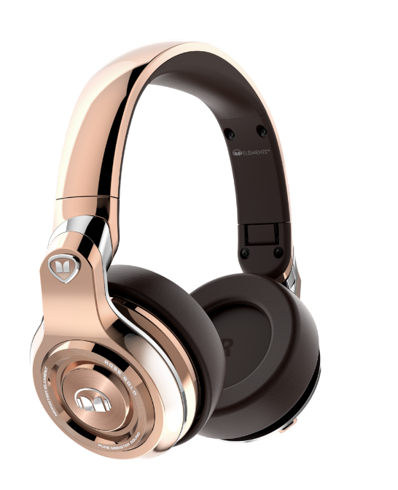
BERLIN, Germany, September 1, 2016 – Monster, the world leader in high-performance personal audio, announced that its highly anticipated Elements Over-Ear wireless headphone are now available for purchase at www.monsterproducts.com. Designed for superior audio performance and the ultra-luxury lifestyle, Monster® Elements are already being embraced by top DJs, celebrities and athletes, who appreciate their uncanny ability to immerse listeners in a world of sound with exceptional comfort and isolation. Elements headphones offer three options for premium listening modes: wireless, wired analog, and via a direct full-digital input, which leverages the Elements’ high-quality D/A Converter for most android devices, and makes them ready for any future devices that may only have digital outputs.

Precision Engineering, Unmatched Build Quality, Comfort and Style
In addition to their outstanding musical capabilities and perfectionist audio, the high-fashion Elements let wearers proclaim their discriminating taste, with a pallet of colors inspired by the natural elements that exude confidence and style. The finish and design reflect the other passions of Head Monster Noel Lee, fine watches and exotic cars. The luxuriant high-gloss and matte finishes on the Elements headphones and laser-etched grooves on the circular outer earcup surfaces, are reminiscent of exotic automobiles. The seamless precision-engineered hinges feature manufacturing quality approaching the tolerances of Swiss watchmaking standards. The ultimate in comfort and convenience are top priorities for Elements, which boast DJ-style swiveling earcups on both sides and super plush, ultra-comfort memory foam cushions on the earcups and headband. Monster innovation is also evident with the touch-swipe controls that offer total ease of volume control and track playback.

The first Elements headphones are being offered in Monster Rose Gold and Black Slate with additional colors to be available later this year. Monster Elements Over-Ear headphones carry a suggested retail price of $349.95 / €349.95 / £279.95. Upcoming models in the Elements family will include a smaller, more lightweight On-Ear model which will retail at a suggested $249.95 / €249.95 / £199.95 , as well as a low-profile, slim and fashionable In-Ear headphone.

Thanks to advanced Bluetooth 4.0 with aptX, and custom tuned by Monster, Elements headphones reliably deliver the powerful listening experience of Pure Monster Sound™ wirelessly—with tight and deep bass and powerful dynamics for the ultimate in emotional impact. In addition, the expert sound-smiths at Monster have created two custom sound profiles to choose from, “Natural” and “Club,” so you can adjust your music-listening sessions to personal preferences and moods.

Also great for calls, Elements’ feature built-in high intelligibility microphones and Active Echo Suppression to ensure crystal clear communication.

The Elements headphones have tremendous battery stamina, offering around the clock 24 hours of playing time and weeks of standby power. Monster includes a stylish zipper travel case, for convenient storage of the headphone plus the included 1/8 “ stereo analog cable, ¼ “ DJ adaptor, Direct Digital audio cable (USB micro to USB micro), PC adaptor and cleaning cloth.

To help promote Elements, Monster is launching a “Be In Your Element” campaign which will feature inspiring individuals who are not afraid to break from the norm and proclaim their discriminating taste and bold lifestyle. #BEINYOURLEMENT.

Full list of features for the Elements Over Ears are:
- Pure Monster Sound with advanced Bluetooth 4.0 + apt-X
- 3 Listening Modes: Wireless, Wired, USB direct full Digital
- Dual Sound Modes: Natural and Club
- Active Echo Suppression Technology
- Cutting-edge on-ear swipe controls
- 24 hours listening at ample level/30 hours talk time/20 days standby
- Super-plush memory foam cushions
- Compact, portable folding design with swiveling ear cups and ¼” cord adapter for DJs
- Comes with pouch, analog and digital cable

About Monster
For the past 36 years, Monster® has been a catalyst for innovation and big ideas. Discovering that cables in hi-fi systems influenced the sound, Head Monster Noel Lee developed Monster Cable - an immediate hit. Monster® engineered the sound of Beats® headphones, and has since become the world’s leading manufacturer of high-performance headphones, all featuring Pure Monster Sound™ technology. Today, the company offers advanced connectivity solutions for professional musicians, home entertainment, computing, mobile and gaming, as well as high performance AC Power and conditioning products. Monster® continues to lead in innovation with Monster having been granted over 500 Patents and 100 patents pending worldwide, offering more than 5,000 products in over 160 countries. Monster® also prides itself in helping those who are in less-than-fortunate circumstances through Monster Cares. Above all, Monster® does what it does Because the Music Matters.

Explore the world of Monster at www.monsterproducts.com. To become a fan of Monster® products, please follow us on Facebook (www.facebook.com/monsterproducts) or Twitter (www.twitter.com/monsterproducts).

Trademarks and brands are the property of their respective owners.
# # #

Press Contacts
US - Sara Trujillo, strujillo@monsterproducts.com
EU - Speed Communications, monster@speedcomms.com

To download images of the product please visit http://releasd.com/caef/ifa-2016

