MONSTER ENERGIZES ITS ISPORT FITNESS HEADPHONE FAMILY
WITH NEW MODELS, NEW FEATURES AND COLORS

Monster Innovations Maximize Music Performance and Push the Envelope in its Fitness Headphones, Combining Ultimate Audio with Comfort, Style, Safety and Workout Convenience

BERLIN, GERMANY, September 1, 2016 – Monster®, the global leader in personal audio, is proud to unveil an expanded lineup of its award-winning Monster iSport® Headphone line, The Athlete’s Headphone™ at IFA 2016. Designed to provide fitness enthusiasts with a jolt of “Pure Audio Adrenaline” and help them reach their workout goals, the new iSport line features more innovation and complete range of models including 4 new wireless and 3 new wired options to suit all preferences, style choices and budget requirements. The new iSport wireless models include the In-Ear Achieve BT (SRP: $59.95 / €59.95 / £59.95), Intensity BT (SRP: $79.95 / €79.95 / £79.95) and Victory BT (SRP: $99.99 / 99.95 / £99.95), along with a new On-Ear Freedom v2 ($199.99 / €199.95 / £199.95). The new wired models include Achieve (SRP: $29.95 / €29.95 / £29.95), Strive v3 (SRP: $39.95 / €39.95 / £39.95) and Compete (SRP: $49.95 / €49.95 / £49.95) models.

The iSport Concept: Headphones As Fitness Gear
Monster launched its first critically-acclaimed iSport™ fitness headphone six years ago, based on the bold concept that headphones are as important as any other fitness gear – such as apparel, sneakers, helmets, goggles, etc. Since then, Monster has continued to push the envelope in fitness headphones, providing athletes and fitness enthusiasts its signature pulse-pounding Pure Monster Sound™ with unprecedented clarity and range from all genres of music to help increase their performance. All iSport fitness headphones are sweat-proof and washable and feature a durable, shock proof design and right angle connectors to improve durability. Recognizing that ear shapes vary greatly, Monster engineered three separate sizes of ear-tips and created patented SportClip ear hooks that keep the headphones comfortable and secure, even during high intensity movement. The iSport line includes models with differing sound isolation properties, allowing athletes to be aware of their surroundings to their optimal preference.

Noel Lee, the Head Monster, noted: “As today’s fitness, sport and active lifestyle culture continues to grow, headphones geared toward athletic-minded music lovers have become the fastest growing segment in the CE industry. Monster has been leading the way in unprecedented growth of fitness headphones since the beginning, and we’re proud to continue driving the segment with the launch of our latest iSport models.”

New High-Performance Wireless Models Bring More Choices to Active Users
Monster’s new wireless iSport models offer users more high-performance choices suited to today’s active lifestyles and sports activities. The ultra-lightweight new models feature the latest fashion colors in training apparel, attractive styling, specially engineered angled tips that form to your ears for unmatched comfort during workouts and in-line mics for uninterrupted ease of calling. They also deliver the latest convenience features like Universal ControlTalk™ for hands-free use, plus a wireless range of at least 30 feet on all models, with sound as good as wired and at least 5+ hours of consistent playback time for even the longest workouts.

The new iSport wireless models consist of the following:
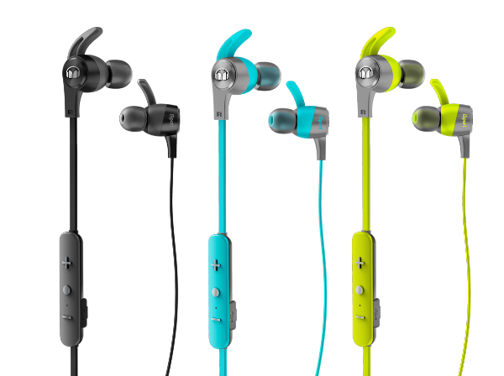
iSport Achieve BT (SRP: $59.95 / €59.95 / £59.95)
- Durable and sweat-proof
- High isolation factor for focus
- One universal anti-microbial ear-hook with multiple ear-tips for perfect fit
- Low profile, flat cable
- Three Button ControlTalk™ lets users Play/Pause their music for on-the-go calls
- 5+ hours playback time
- Available in Black, Blue and Green

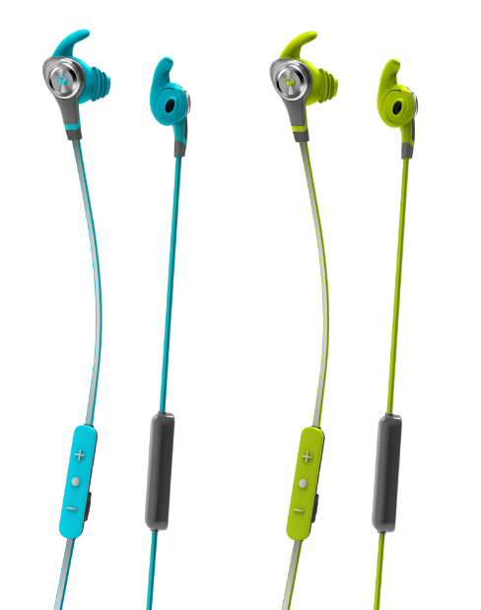
iSport Intensity BT (SRP: $79.95 / €79.95 / £79.95)
- NEW reflective cable for extra safety in low-light environments
- Durable and sweat-proof
- Hybrid noise isolation
- Multiple anti-microbial ear-hooks for perfect fit
- Premium finish with high quality touch and feel
- USB charging cable and carry pouch
- 3-button Universal ControlTalk™ with Micro USB Charge point
- 6+ hours consistent playback time
- Available in Blue and Green

iSport Victory BT ($99.99 / 99.95 / £99.95)
- NEW premium, smaller design
- NEW Two sound-engineered Monster Sound profiles (warm-up and sport) so you can customize your workout audio experience
- NEW twisted, reflective cable for extra safety in low-light environments
- Durable and sweat-proof
- Patent-pending airtight OmniTip™ that offers ease of fit for any ear shape
- Multiple sized ear-tips
- High sound isolation, targeted at activities requiring a high level of concentration
- 8+ hours playback
- Available in Black, Blue and Green

iSport Freedom v2 ($199.99 / €199.95 / £199.95)
- Cutting Edge Touch Sensing Controls for play/pause, tracking and volume
- Three Listening Modes (wireless, wired and USB Direct Digital Audio)
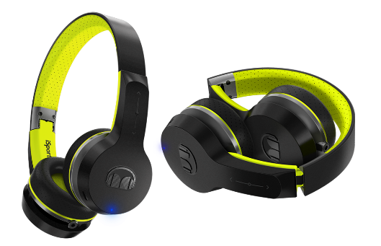
- Two Different Sound Profiles (standard and “turbo” mode)
- Pair Two Devices to share music
- Low battery voice prompts and indicator LED’s
- Built in high-intelligibility mic with advanced echo suppression
- Superior wireless performance (Apt-X)
- Durable and sweat-proof
- Available in Black

In addition to the new wireless models, the new Monster iSport Wired models include:
iSport Achieve (SRP: $29.95 / €29.95 / £29.95)
- One universal ear-hook
- High sound isolation
- In-line microphone
- Low profile flat cable
- Available in Black, Blue and Green
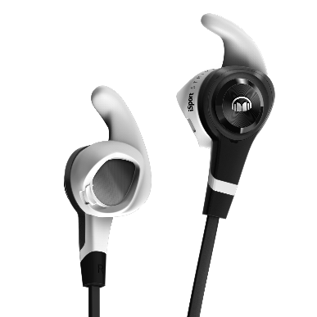
iSport Strive v3 (SRP: $39.95 / €39.95 / £39.95)
- Three sets of patented SportClip™ for perfect fit
- Sweat proof and durable
- Anti-tangle cable
- Partial noise isolation – great for outdoor running
- In-line microphone
- Mic for Hands-free Calling
- Available in Black

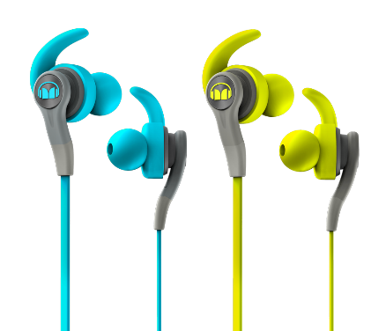
iSport Compete (SRP: $49.95 / €49.95 / £49.95)
- Includes three sets of ear-tips for perfect fit
- High sound isolation, targeted at activities requiring high level of concentration
- One-button ControlTalk™ for hands free calls
- New ergonomic in-ear shaping designed to provide extra comfort and stability
- Carry Pouch for Convenience
- Available in Blue and Green

ABOUT MONSTER
For the past 35 years, Monster® has been a catalyst for innovation and big ideas. Discovering that cables in hi-fi systems influenced the sound, Head Monster Noel Lee developed Monster Cable - an immediate hit. Monster® engineered the sound of Beats® headphones, and has since become the world’s leading manufacturer of high-performance headphones, all featuring Pure Monster Sound™ technology. Today, the company offers advanced connectivity solutions for professional musicians, home entertainment, computing, mobile and gaming, as well as high performance AC Power and conditioning products. Monster® continues to lead in innovation with Monster having been granted over 500 Patents and 100 patents pending worldwide, offering more than 5,000 products in over 160 countries. Monster® also prides itself in helping those who are in less-than-fortunate circumstances through Monster Cares. Above all, Monster® does what it does Because the Music Matters.

Explore the world of Monster at www.monsterproducts.com. To become a fan of Monster® products, please follow us on Facebook (www.facebook.com/monsterproducts) or Twitter (www.twitter.com/monsterproducts).

Trademarks and brands are the property of their respective owners.

# # #

Press Contacts

US/Global - Trujillo Public Relations, Sara Trujillo, sara@trujillopr.com
Europe – Speed Communications, Monster@speedcomms.com

To download images of the product please visit http://releasd.com/caef/ifa-2016

