TAKE THE PARTY WITH YOU!
INTRODUCING THE MONSTER SUPERSTAR™ RAVEBOX FEATURING
POWERFUL SOUND AND A SPECTACULAR LIGHT SHOW

First-of-Its-Kind Portable RAVEBOX Joins Blaster and Hot Shot in Monster’s Hugely Popular Family of Party-Friendly SuperStar Bluetooth Speaker Products

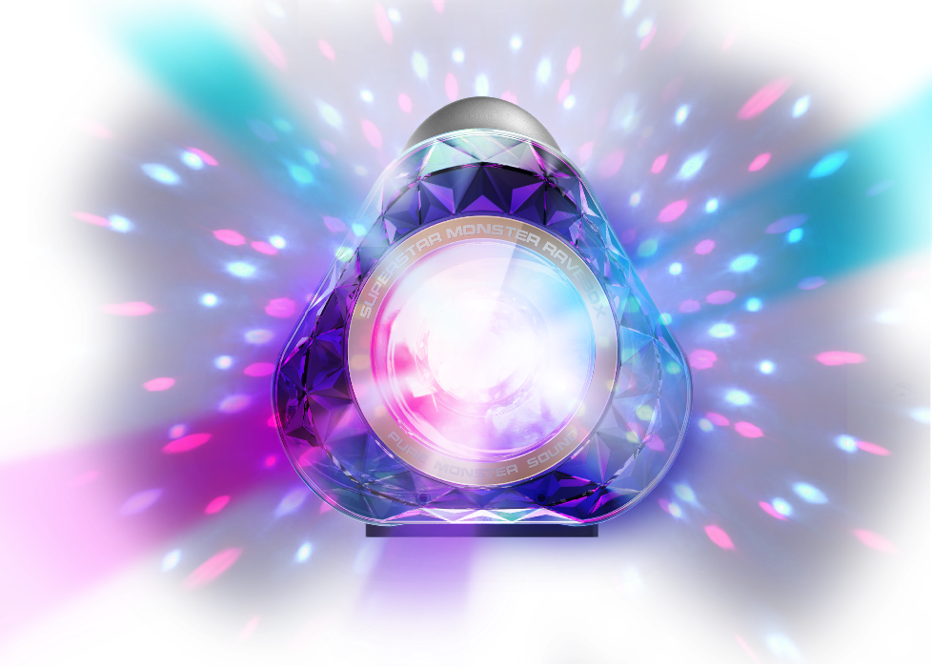
BERLIN, GERMANY, September 1, 2016 – Monster®, the world leader in high-performance personal audio, is proud to debut the Monster SuperStar RAVEBOX at IFA 2016. The first-of-its-kind SuperStar RAVEBOX loudspeaker truly lets you take the party home, with a dazzling kaleidoscope of sight and sound that pulses to the beats of your music. The introduction of the party-friendly RAVEBOX is the latest addition to Monster’s trendsetting family of portable SuperStar Bluetooth loudspeakers, which also includes the Monster Blaster, super compact Hot Shot, BackFloat and the original SuperStar. The Monster SuperStar RAVEBOX will be available from October at selected retailers.

Modern Reimagining of the Boombox – A Party in a Box!
The new Monster SuperStar RAVEBOX, like its counterpart the Monster Blaster, is a modern reimagining of the classic ‘80s Boombox for today’s youth and mobile cultures. In addition to its mesmerizing light show capabilities, the RAVEBOX offers the same powerful high-wattage bi-directional sound as the Blaster, with full and deep bass, Bluetooth and USB connectivity, as well as classic styling that will look great on anyone’s shoulder or at any social gathering. Best of all, the RAVEBOX has 12 hours of continuous battery power, so you can literally dance the night away! Both models feature an integrated handle and water-proof all-weather design make it easy to bring the party virtually anywhere. Adding to their modern convenience features, both models feature a USB charging port to recharge smartphones while partying.

Room-Filling Music and Amazing Light Show
Both the Monster RAVEBOX and Blaster incorporate innovative design and technology including a V-shaped angled cabinet with drivers on both sides that project on either side of the speaker. This creates direct and reflected sound that comes towards you and bounces off the wall to create a completely immersive experience that Monster calls V-Sound™. They also feature Monster’s proprietary PowerBass™, an integrated powered subwoofer for real bass response. Another feature is the Indoor and Outdoor Dual EQ Voicing Profiles that optimizes the sound for any environment, and enhances bass further for outdoor listening sessions. All SuperStar speakers benefit from one of today’s most advanced audio concepts, Monster’s signature Pure Monster Sound™. Pure Monster Sound uses Monster’s latest proprietary technologies to offer the full experience of live music, with outstanding clarity, dynamics, articulation, and tight bass.

SuperStar Hot Shot: The Most Compact in the Monster Super Lineup
Rounding out the SuperStar line is the SuperStar Hot Shot, the most compact of Monster’s portable wireless speakers. While small enough to clip to a backpack, jacket or belt loop, the Hot Shot packs a sizeable punch with portable Pure Monster Sound®. It’s rugged, tough and very easy to use — with NFC Tap 2 Pair feature — super portable, with carabiner clip included, and long 5.5 hour play life. And Hot Shot is also a great speakerphone! The Monster SuperStar Hot is available in Black/Grey, Black/Gold, White/Silver combinations.

Meet The Superstar Family
Monster SuperStar Ravebox (MSRP of $449.95 / €449.95 / £399.95)
Monster Blaster (MSRP of $349.95 / €349.95 / £299.95)
SuperStar BackFloat (MSRP of $149.95 / €149.95 / £119.95)
SuperStar (MSRP of $99.95 / €99.95 / £79.95)
Superstar Hot Shot (MSRP of $49.95 / €49.95 / £39.95)
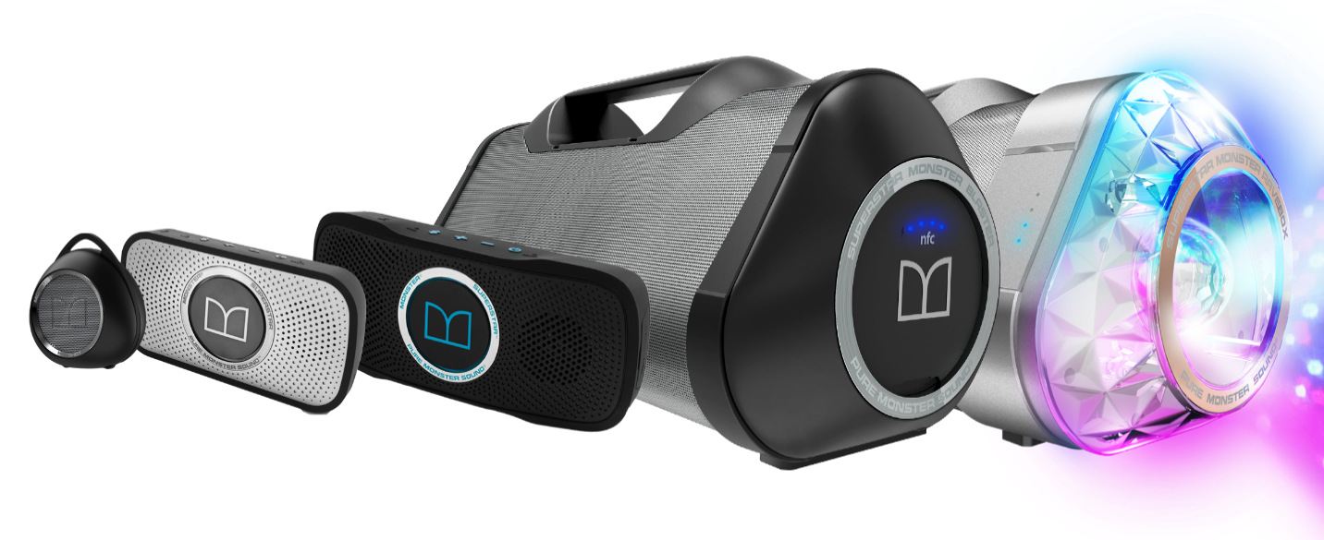
All current models can be purchased at monsterproducts.com / monsterproducts.eu and selected retail stores. Superstar Ravebox will be available to purchase in October.

ABOUT MONSTER
For the past 35 years, Monster® has been a catalyst for innovation and big ideas. Discovering that cables in hi-fi systems influenced the sound, Head Monster Noel Lee developed Monster Cable - an immediate hit. Monster® engineered the sound of Beats® headphones, and has since become the world’s leading manufacturer of high-performance headphones, all featuring Pure Monster Sound™ technology. Today, the company offers advanced connectivity solutions for professional musicians, home entertainment, computing, mobile and gaming, as well as high performance AC Power and conditioning products. Monster® continues to lead in innovation with Monster having been granted over 500 Patents and 100 patents pending worldwide, offering more than 5,000 products in over 160 countries. Monster® also prides itself in helping those who are in less-than-fortunate circumstances through Monster Cares. Above all, Monster® does what it does Because the Music Matters.

Explore the world of Monster at www.monsterproducts.com. To become a fan of Monster® products, please follow us on Facebook (www.facebook.com/monsterproducts) or Twitter (www.twitter.com/monsterproducts).

Trademarks and brands are the property of their respective owners.

# # #

Press Contacts

US/Global - Trujillo Public Relations, Sara Trujillo, sara@trujillopr.com
Europe – Speed Communications, Monster@speedcomms.com

To download images of the product please visit http://releasd.com/caef/ifa-2016

