EMBARGO: Please mind the press embargo until August, 31st 2016

udoq is the first universal docking station for all your mobile devices of every brand and generation

udoq is compatible with all mobile devices, supports every brand and generation and helps reducing electronic waste
- udoq makes the search for chargers, cables as well as your mobile devices obsolete
- patented worldwide* premium-quality design “Made in Germany”

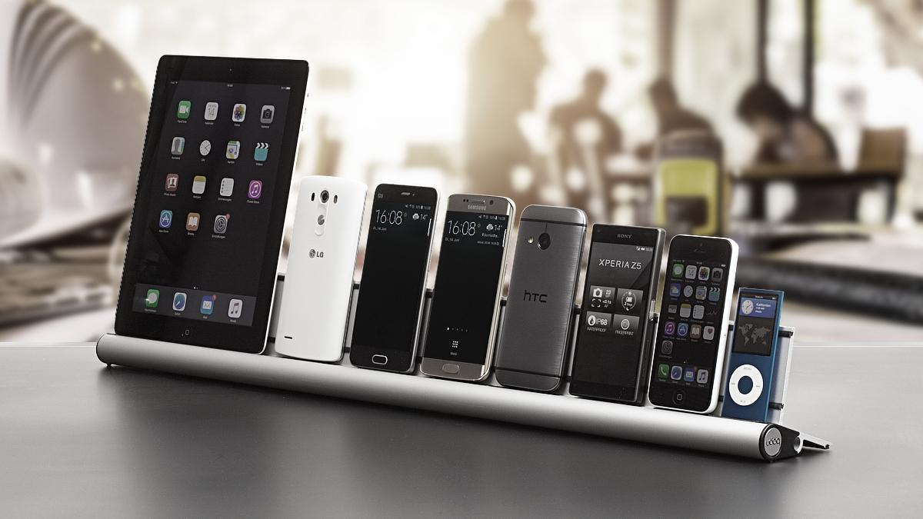

Concept
udoq is the first universal docking station that is customizable to the needs of their users. No matter if you own two or eight mobile devices - udoq fits them all. Your Smartphones, Tablets, eReaders and Music Players are organized side by side in the quantity and order you need. All mobile devices synced on udoq remain 100% operational, while getting charged. Different lenghts of udoqs (available in 250mm (9,8 in), 400mm (15,7 in), 550mm (21,65 in) and 700mm (27,6 in)) and the possibilty of switching and shifting your charging cables, customize your udoq for all mobile devices of every brand and generation.

Vision
Marcus Kuchler, founder of udoq and father of two boys, was constantly annoyed by the daily search for several charging cables of multiple mobile devices of different brands within his family. He craved for a simple yet elegant solution, organizing the chaos. At the same time, he thought about the tons of electronic waste caused by ever-changing cable types as well as docking stations with only one, non-changeable connector. Udoq is the answer to both problems and provides long-term compatibility for today's and future mobile devices.

Product
Depending on the personal number and size of your mobile devices you can user-define your udoq bar individually. You can compile your personal udoq via the website-configurator. udoq will be available from October ‘16 in the online-shop and at selected retailers. udoq comes as a plug & play product: the four most common charging cables (Apple Lightning, Apple 30-pin, Micro-USB and USB-C) are already installed in the udoq bar. Additional cables of every type can be added at all time as required.

About founder Marcus Kuchler
udoq (www.udoq.com) was invented and designed by Mag.Art. Marcus Kuchler over the course of the last three years. Since 1990 he has been inventing, developing and designing products for major brands all over the globe with his product design company marwin. The marwin team of designers and engineers oversees hundreds of projects in various branches and categories and form an incredibly effective team to create innovative and timeless classics. udoq has its registered office in Munich.

* Patent applications (status 06/20/2016):
EU-PATENT (PCT), applied for 02/03/2016 under No. 2776898 Status: granted
US-PATENT, applied for 01/03/2016 under No.14356758 Status: granted
JAPAN-PATENT, applied for 02/19/2016 under No. 2014-540496 Status: granted
CHINA-PATENT, applied for 09/10/2014 under No. 201280066666.6 Status: pending

Further press information and high resolution images you can download on the udoq-website or here: http://bit.ly/press-kit-udoq

Press contact: Joschka Rugo I press@udoq.com I +49.30.27595973.14

